**The class Car with 2 data members: owner and price is given.**

**The BSTree class is a binary search tree of Car objects.**

**The variable price is the key of the tree. The following methods should be completed:**

**• def insert(self, name, price) - check if xOwner start with = 'B' or xPrice>100 then do nothing,**

**otherwise insert new car with Name=name, Price=price to the tree.**

**Input.txt**

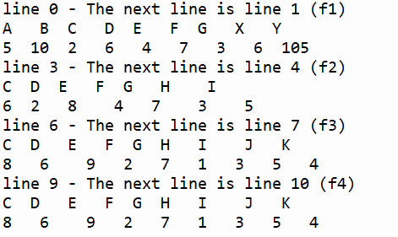

**Q2.1**

**Complete the insert(...) function**

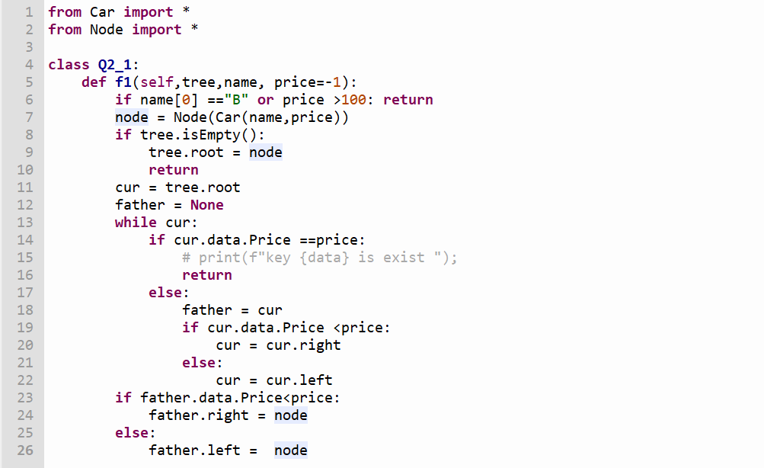

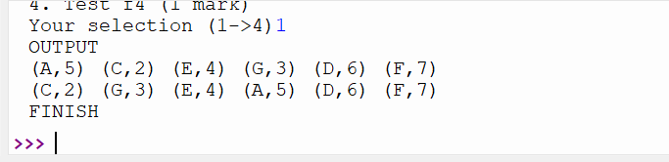

**Q2.2**

**Perform pre-order traversal from the root but display to file f2.txt nodes having**

**price in the interval [3,5] only.**

**Copy the function preOrder(...) to preOrder2(...) and**

**modify it.**

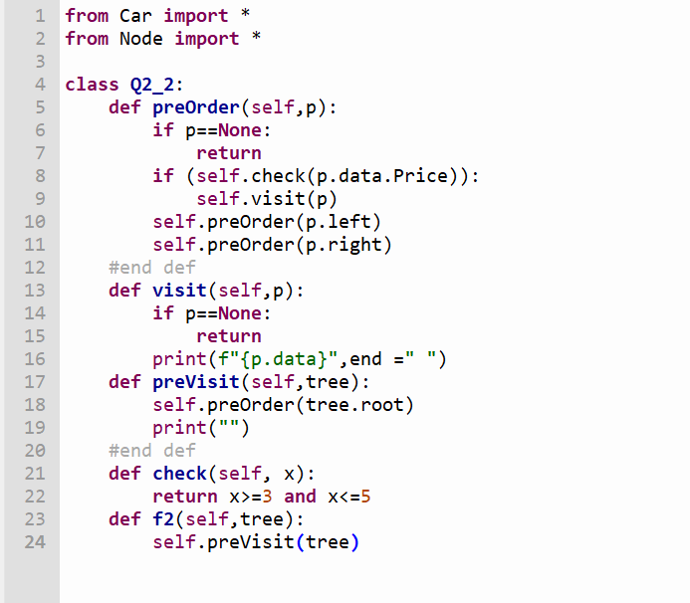

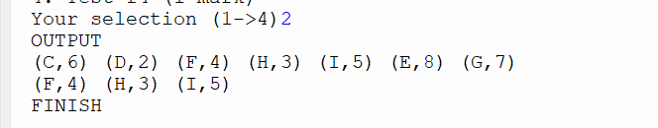

**Q2.3**

**Perform breadth-first traversal from the root and delete by copying the first node**

**having both 2 sons and price < 7.**

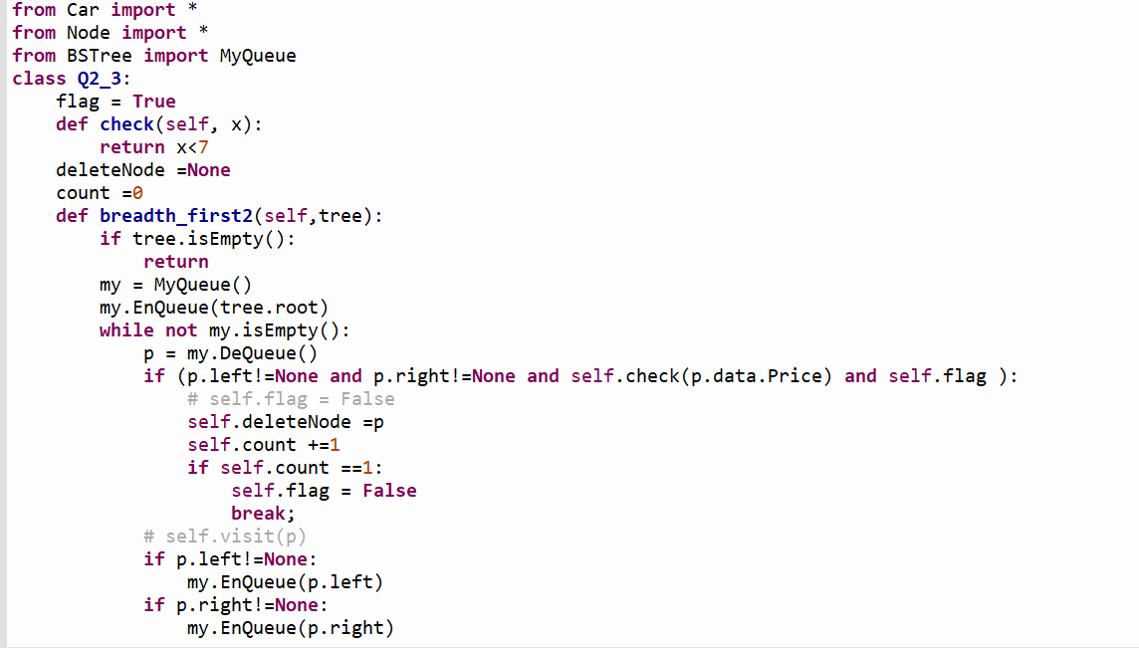

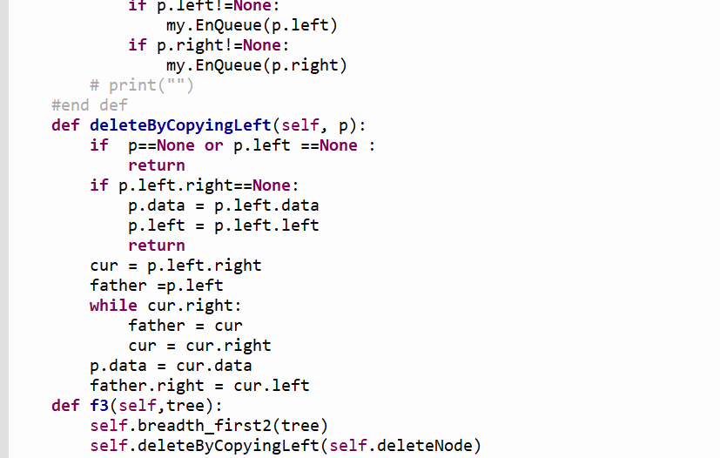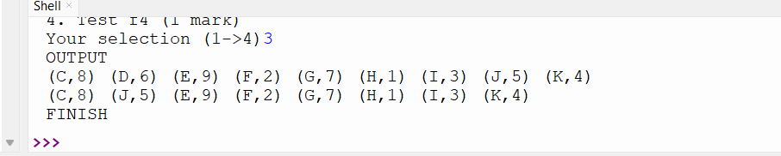

**Q2.4**

**Perform breadth-first traversal from the root and find the first node p having left**

**son and price < 7. Rotate p to right about its’ left son.**

